An App – “Cinematic”

C19366991
Jude Abouhajar

Description
The objective of this project is to take advantage of emerging and existing mobile technologies to develop a smart phone mobile application designed to be targeted towards cinema goers.
To achieve these aims, this project will be implemented on Google’s Android operating system for use on the many Android devices currently available.
The application will provide a platform for action movie-lovers/cinema goers to pick and choose what movie or genre they’d like to watch and any cinema locations close by. Each movie shown to the user will include a movie description, the genre and the duration as well as any other relevant information such as the actors in the movie and ratings. The app will also provide a comment section for each movie for anyone who wants to leave their opinions for others to view and respond to and have discussions. The user will also have the option of buying tickets on the app.
The home page will include all new action movie releases.
. . .as well as providing interactivity and social aspects to enhance their experience. If the user has a favourite book they’d like to see on the big screen (but the book hasn’t been made into a movie), they can take a photo of the book and upload it, and the system will find similar genre movies for the user. On top of that, the user has the option to be part of the movie. The system can offer multiple choice options during the movie, available on the users phone that can change the plot. (The user can also have the choice of having a 3D view of the landscape from the movie from the comfort of their phone. Simply by using the control system visible on the phone’s screen, they’ll feel like they are in the movie.)
Instead of controlling the view of the landscape from your phone as mentioned in the paragraph above, if users go to the cinema they can use VR glasses provided by the cinema where they can wear and have a view of the landscape. The cinema can also provide an omni-directional treadmill if they wish to walk around in their selected movie landscape. To connect to the VR headset, the user will scan a QR code through the app, and sign in once the screen in loaded. The user will then be given a selection of movie landscapes they wish to be in, on their phone.

The project will choose an appropriate architecture to appeal to a user who are interested in movies and going to the cinema, as well as VR.

Requirements Engineering

Feasibility Study
- Are there apps similar to this in the marketplace (in Android, iOS, Windows …)?
Identify at least 4 examples of Similar Apps. Briefly describe each of them. Reference the URL for each.
- myODEON app – an app that shows all the movies and times for all Odeon branches. It also includes movie descriptions. https://play.google.com/store/apps/details?id=nz.co.vista.android.movie.odeoncinemas&hl=en_IE&gl=US
- IMBd web app– is a website that holds information on movies, tv shows, home videos and video games. This information includes cast, production crew, plot summaries and reviews. https://www.imdb.com/
- Flixster app – provides rating and reviews for each movie. Users can buy tickets here too. This app also provides reviews from viewers and critics along with summaries and trailers. https://play.google.com/store/apps/details?id=net.flixster.android&hl=en_IE&gl=US
- Netflix – a platform that has thousands of shows and movies on demand. It also provides shows where the user can interact with the show and change the plot from home. It allows you to log-in so you don’t lose your progress. https://play.google.com/store/apps/details?id=com.netflix.mediaclient&hl=en_IE&gl=US

- Identify the main system features and services provided in the desired App system. Consider the existing systems and the services they provide.
[Reference and copy the URLs] (min 200 words)
The app would have access to the user’s camera in which they can upload photos of their book onto the app. It would also need to have access to the device’s location so the user can see where the closest cinema is to them, which will include an option to view the cinema’s location in google maps. This feature will also allow the user to buy tickets once the desired cinema is chosen. The app system will prompt the user to log-in so all the data will be saved without interruptions. The system app will only work if there is a stable internet connection.

For the interactive part of the app system, and from looking at how Netflix made their own interactive TV shows, we would have to translate a story-map into a spreadsheet that will be read by a computer [1]. In non-technical terms, the user will be able to select one of two options when prompted to on the screen, in order to progress the storyline as he/she wishes to. The options will be available on their phone through the app as a pop-up, unlike Netflix where it allows the user to choose only from the same device as they are watching the show [2]. There is no limited time for the user to select an option.

(The use of computer-generated imagery and interactive visualization will help the user to view, in the first person, a landscape from the movie from their phone [3]. The user can control where to look with a control system that will show in the corner of the mobile phone. The control system will consist of touch screen buttons where the user can press on up, down, left, and right buttons to control where they want to look. Similar to how league of legends, a mobile game, uses finger control to tell the character where to move [4] )

Based off feedback, VR headsets will be used instead. The user can go to a cinema that has VR headsets in stock and is in collaboration with this system and connect to the headset by scanning a QR code with their phone [5]. The cinema can also provide an omni-directional treadmill if they wish to walk around in their selected movie landscape.

References

[1] “ The Bespoke Technology That Made Netflix’s Black Mirror: Bandersnatch Possible” , 2019, Susannah Edelbaum, https://www.motionpictures.org/2019/05/the-bespoke-technology-that-made-netflixs-black-mirror-bandersnatch-possible/ , 25/09/2022

[2] “The editing and tech behind Netflix’s Black Mirror: Bandersnatch”, 2019, Karen Moltenbrey, https://postperspective.com/netflixs-black-mirror-bandersnatch-lets-viewers-choose/#:~:text=Viewers%20have%2010%20seconds%20to,the%20movie%20is%2090%20minutes. , 25/09/22

[3] “Visualization (graphics)”, Wikipedia, https://en.wikipedia.org/wiki/Visualization_(graphics)#Interactivity , 25/09/2022

[4] “HELLO RIOT MOBILE! FAREWELL LEAGUE+” , 2021, Lex White, https://www.leagueoflegends.com/en-us/news/riot-games/hello-riot-mobile-farewell-league/ , 25/09/2022

[5] “How do you scan a QR code with a VR headset?”, 2022, https://xgamesnorway.no/how-do-you-scan-a-qr-code-with-a-vr-headset/ , 09/11/2022

- In what ways do current users get/use their information, when not using the desired app?
Users could also go to the cinema to purchase cinema tickets.
Current users may get cinema/movie information from a newspaper that may have a section for movies, or the radio. Or perhaps they can find out information from friends and family. There’s also the choice of going to the local cinema and seeing film times.
Users could also go to the cinema to purchase cinema tickets.
User could also use “Google” to find which movie they’d wish to watch by searching for movie descriptions.

- Describe a new type of desired App system and how it might operate. Consider existing systems that provide services to users and organisers.
Take inspiration from the systems identified in section 1 and key features identified in section 2.
I will be taking inspiration from multiple apps that offer only one of each service that I am looking for, to implement in my new app system, as I found that most cinema/movie applications don’t offer a lot of services in the one place and I have to jump between apps to find what I want. To ensure the success of this project, we’ll need to narrow it to a specific niche. I’ve decided to target this app towards people who enjoy watching action movies, and enjoy reading action books.

This app will allow for the user to search for and find any movie they are looking for. With each movie, there will be information on the movie name, description, actors, critic reviews, ratings, duration and which cinemas you can watch the movie in. Underneath each movie, there will be a comment section where users can have discussions with each other about the movie and share their opinions. Along with that, the app will allow the user to buy tickets for their desired movie, as well as being able to find out which cinema is closest to them with google maps. The user can also open the cinema location in google maps so they can find directions to the cinema.

There will also be another section where the user can upload a photo of a book onto the app. The user can upload a photo of a book onto the app . They can do so by taking a photo on their phone or selecting an image from their gallery. The purpose of this is to allow the user to find a movie that has a similar description to the book they uploaded, or the movie version of the book. This is successful when the system reads the title of the book from the image and searching the database.

The app will allow the user to refund a ticket 24 hours before the showing time. It cannot be refunded within 24 hours of the showing. The user must also have proof of purchase and the same card they bought the ticket with.

The home page will include all new action movie releases.
Lastly, the user has the option to be part of the movie. The movie can offer multiple choice options during the film that can change the plot or a situation. The options will be available on the user’s phone as a pop-up, as they are watching the movie.

(The user can also have the choice of having a 3D view of the landscape from the movie from the comfort of their phone. Simply by using the control system visible on the phone’s screen. The control system will consist of touch screen buttons where the user can press on up, down, left, and right buttons to control where they want to look.)

Instead of controlling the view of the landscape from your phone as mentioned in the paragraph above, if users go to the cinema they can use VR glasses provided by the cinema where they can wear and have a view of the landscape. The cinema can also provide an omni-directional treadmill if they wish to walk around in their selected movie landscape. To connect to the VR headset, the user will scan a QR code through the app, and sign in once the screen in loaded. The user will then be given a selection of movie landscapes they wish to be in, on their phone.

- Who are the stakeholders? Would this app affect them positively or negatively?
The stakeholders for this app would be:
- Sponsors
- Team members
- End users such as: marketing, finance and administration.
- The public
- Legislation and regulation
- Managers
- Client

This app would create a positive affect for all stakeholders involved. Based on an article I’ve read, “Irish people can't resist an old trip to the movies and it continues to have the highest rating in Europe for cinema attendance per capita.”

References

[1] “Ireland is number one in Europe for cinema attendance”, 2017, JOE, https://www.joe.ie/movies-tv/irelands-europe-cinema-attendance-592294 , 01/10/2022

- What other research would be necessary to ascertain feasibility e.g., ownership of smartphones …? (Gartner Research etc.)
Interviews conducted asking potential users how often do they visit the cinema or use film-related phone apps, or enjoy using VR headsets.
Statistics on how many users enjoy interactive TV.

From reading a report online [1], “The Irish Immersive Technology sector is worth over €43 million, with huge future potential.” VR is growing in Ireland and with the entertainment industry increasing each year, my system would be very relevant.
From this article, it is clear that the interactive ‘Black Mirror: Bandersnatch’ episode was successful. It reported back positive results - to the point that Netflix is “now making moves to create interactive content”[2]. I hope, from this article, that any user will enjoy the interactive movies in my system and will come back for more.

References

[1] “The Irish Immersive Economy Report”, 2022, The Irish Immersive Economy, https://www.skillnetireland.ie/wp-content/uploads/2022/04/The-Irish-Immersive-Economy-report.pdf , 09/11/22

[2] “More “interactive” shows are coming from Netflix, thanks to ‘Black Mirror: Bandersnatch’ ”, 2019, Brian Lloyd, https://entertainment.ie/on-demand/on-demand-news/more-interactive-shows-are-coming-from-netflix-thanks-to-black-mirror-bandersnatch-388534/ , 09/11/22

- Make an initial list of functional and non-functional requirements.
Functional:
- Information is required to display correctly such as:
  - Movie times
  - Cinema locations
  - Movie description
  - The correct options displayed
  - The plot must be updated when the user chooses an option.
- In-app purchases to buy cinema tickets
- Camera access to upload book image
- Location access to use google maps
- Confirmation needs to be sent to the user for buying cinema tickets.
- VR glasses to use in the cinema
Non-functional:
- Reliability: the system must be working almost 99% of the time so users can purchase a ticket at whatever time they desire.
- Delivery: tickets and times for new movies need to be uploaded and delivered in time for when the cinemas are showing the movies.
- Response time: response time needs to be quick. Cinema tickets may sell out especially any popular new releases.
- Legislative: the users payment details must be kept private as well as their personal details when making an account.
- Usability : the system must be simple, intuitive and not-complicated.
- Privacy: when users make in-app purchases or allow access to their gallery, their privacy needs to be protected.

Requirements Elicitation

- Could ethnographic methods be used in this case study? If so, in what way?
Yes.
You could observe people at the cinema and see if they already bought tickets from an app or if they go to the cinema and then buy tickets there. You can also observe if they have pre-checked movie timings on an app or already read the movie summary prior to going to the cinema, instead of going to the cinema to check timings/summaries.

- Identify a significant stakeholder(s), which will be interviewed to get more information on the intended product.
Justify your choice of stakeholder(s).
Do up an interview plan and pre-prepare approximately 10 questions.

- People who enjoy action movies (the public): the public is a significant stakeholder since the app is intended for the public to use for entertainment purposes, to go to the cinema and watch movies.

Before interviewing people, I would conduct research such as following up on statistics and read up on previous interviews relating to cinema/film apps.

Purpose of interview: meeting to obtain more information on the product.

Questions:

- How would you describe your experience with any cinema/film related apps?
- How often do you see yourself using this app?
- What is your main goal when visiting cinema/film related apps?
- What devices do you typically use when wanting to obtain information on cinemas and movie times?
- How do you feel about an interactive app?
- How do you feel about VR glasses?
- What was the hardest part about buying cinema tickets? Would an app solve this?
- Tell me about the last time you went to the cinema.
- Do you feel this product is suited for you? Why or why not?
- How do you feel about in-app purchases?

- Identify a significant group of stakeholders, which will receive questionnaires.
Justify your choice of stakeholders.
The questionnaire should have approximately 10 questions.
- Marketing: people involved in marketing are also significant because they will be responsible with advertising the app. They also have previous experiences with other move-based apps so their input would be important.

- Legislation: the app would need to be both ethical and legal, especially since online purchases are possible in this app, attention needs to be given to children and people under 16 to ensure they don’t make any non-approved purchases.

- Finance: people involved in finance would know the costs involved into making this app and to ensure its success. They would know how much we should spend on marketing, and building the app system.

- Development team: the people involved in the development of the app are the key stakeholders as without them, the app wouldn’t exist. Their input is extremely valuable.

- People who enjoy action movies (the public): the public is a significant stakeholder since the app is intended for the public to use for entertainment purposes, to go to the cinema and watch movies.

Questions

- Are you satisfied with purchasing cinema tickets online? Yes/No
- Is the target market big enough? Yes/No
- What would make our app stand out from the others? List your suggestions _________
- Are there any improvements that could be made to this app to have a wider reach? Yes/No
- What guidelines would we establish for this app?
- How should we keep collected personal information safe?
- What are the national laws we need to keep in mind for this app?
- Is there much competition for this app? Yes/No. If so, who? __________
- What would you suggest the budget should be for the success of this app, in terms of marketing, insert estimate in numbers here: ______________
- How should we ensure robust security in the app?
- Does this app solve existing problems? Yes/No
- Are there other tools we should integrate with?

Requirements Analysis

- Use the use case template to analyse the proposed system

Draw an initial use-case diagram with supporting scenario description for this app (possibly using StarUML for the diagram).
The first iteration of the use-case diagram can consist of a single overall use case with supporting main flow and 2 or 3 alternative flows.
The use case description is developed from analysing the description of the use case. This is the statement of the goal of the use case.

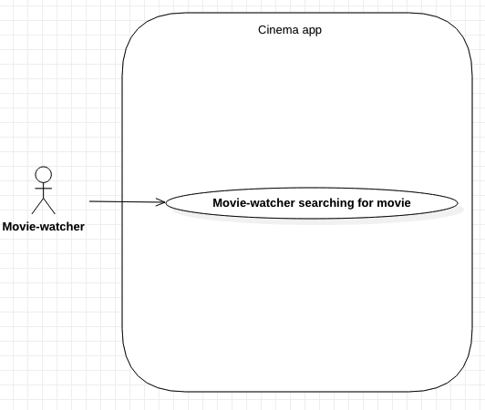

For the first iteration this will be a description of the how the system operates.
Use Cases focus on functional requirements and specific system behaviour.

USE CASE |  | 1 | Movie-watcher searching for movie.
Description of Goal in Context |  | Movie-watcher can find the desired movie.
Preconditions |  | Movie-watcher has a movie in mind.  Movie-watcher would like to find out information on the movie.  Movie-watcher has access to the internet.
Post Conditions, Success End Condition |  | Movie-watcher successfully finds the correct movie.
DESCRIPTION |  | Movie-watcher will have a movie in mind and they would like to know information on the movie. They will have to search for the movie in the app’s search bar, and the system will provide information on the movie name, description, actors, critic reviews, ratings, duration. This section is the main section as the movie-watcher can purchase a ticket here.
Main Flow
Step | Action |  |  | Alternate
1.1 | Movie-watcher inputs the movie name.
1.2 | The system app searches for the movie.
1.3 | The system loads all possible movies. |  |  | E.F.1.3
1.4 | Movie-watcher selects their desired movie.
1.5 | The system loads the movie along with all the information.
1.6 | The system updates movie-watcher’s search history
1.7 | End Use Case
EXCEPTIONS or ERROR Flow Description
Step | E.F.1.3 |  |  | Alternate
1.3.1 | The system states that the movie name they entered is wrong/does not exist in the database.
1.3.2 | The system prompts the movie-watcher to enter the name of the movie correctly.
1.3.3 | Back to Main Flow Step 1.2 |  |  | M.F.1.2

Non-functional Requirements for each use Case can be added in the Table below
Non-functional requirements, management issues and decisions required to be made, can be identified in the following table.
From the table below, choose a limited number of appropriate non-functional requirements relevant to the Use Case.
Non Functional Requirements can be categorised as
- Product related
- Organisation related, process and approaches set by the company
- External, imposed by outside bodies

RELATED INFORMATION | Use Case: 1 | Using the system to find movie information
Priority: | High priority as it gives the user the chance to see if they want to pay for and watch this movie, this is also the main section where most features are available.
Product: Performance | Quick response time.  The system needs to show the information within 1 minute of selecting the movie.

More Systems Analysis

- Develop a second iteration in a separate word report consisting of 4 or 5 use cases. Each use case requires a use case narrative describing the scenario analysis. Each use case should have 2 or 3 exception or alternative flows

Requirements Specification Matrix

- From the requirements analysis identified with the use Case scenario analysis identify key functional requirements.

There should be 6 to 10 easily identifiable feature or requirements that can be listed in this matrix.
All the use cases identified previously need to be included and review section 7 for additional features

H = high priority
M = Medium priority
Req ID | Name of Req | Description | Priority | User Contact
1 | Purchase ticket | Log into account and purchase a cinema ticket | H | Ticket-purchaser
2 | Locate cinema location | View cinema location based on the movie-watcher’s current location | M | Cinema-goer
3 | Upload comment | Log into account and upload a comment in the comment section | M | Movie-watcher
4 | Uploading image | Log into account and upload an image of a book and system returns a movie. | H | Movie-watcher
5 | Change plot | Log into account and watch a movie. The system will provide the movie-watcher with options that will change the movie’s plot. | H | Movie-watcher
6 | VR headset | Scan QR code and log into account and connect to VR headset. | H | VR-fanatic
7 | View purchases | Purchaser can Log into account and view previous purchases. | M | Ticket- Purchaser
8 | Search movie | Movie-watcher can search for the movie in the system and the system will return the correct movie. | H | Movie-watcher
9 | Log in | All users mentioned above should be able to log into their account to access some of the features. | H | All users from above ( Ticket-purchaser, Movie-watcher, Cinema-goer, VR-fanatic)

System Modeling

From the systems analysis and the requirements table additional features and actors can be identified.
Normally this would be done through additonal Use Case models ( diagrams and narratives).
At this stage the aim is to list what would be needed to complete the model in a list by reviewing the requirements table and the systems analysis models.

- List all the possible actors in this system.
- Movie-watchers
- Cinema-goers
- Movie-goer
- VR-fanatics
- Ticket-purchaser
- Book-readers

- List the possible use-cases in this system.
- Search for movie.
- Searching for cinemas
- Finding cinema location
- Uploading a comment
- Changing movie plot
- Connecting to VR headset
- Make account
- Replying to a comment
- Uploading image of book from gallery
- Uploading image of book from phone camera
- View previous purchases
- Purchase a ticket
- Return a ticket
- Log in
- Log out

Verification and Validation of Requirements

- Test Case Planning.

Develop 2 test cases, one for each of 2 use cases, functional requirements, identified in Iteration 2 of the Use Case Analysis.
Develop 1 test case for 1 non-functional requirement for 1 of the Use Cases.

Use the test case template to create initial Use Acceptance Test plans that will permit users and developers to agree the system will have been developed as specified by the requirements

Consider the test plan as a user guide or user manual for non-technical novice users of the system

Separate document

Completing the Feasibility Study

Review Previous Versions

- Before you complete the final submission of the feasibility report, review and update the nonfunctional requirements, if necessary.

- Review and, if necessary, Update the requirements Specification Matrix, section 13, and identify the high level core system features

An Updated Requirement Specification (RS) & set of Use-Case Diagrams (UCD) with narratives

- Consider the Use case Model to be sure key functionality has been addressed in the analysis and modelling process.

  - Do any of your use-cases need to be broken down further i.e., is there is too much functionality in one use-case?
  - Update the Use Case list in section 15 as necessary.
  - Update your Requirement Specification table with additional requirements as necessary.

Prototype

- Sketch the home page/starting page of the app. You should take a photo of it and insert the photo into the document.
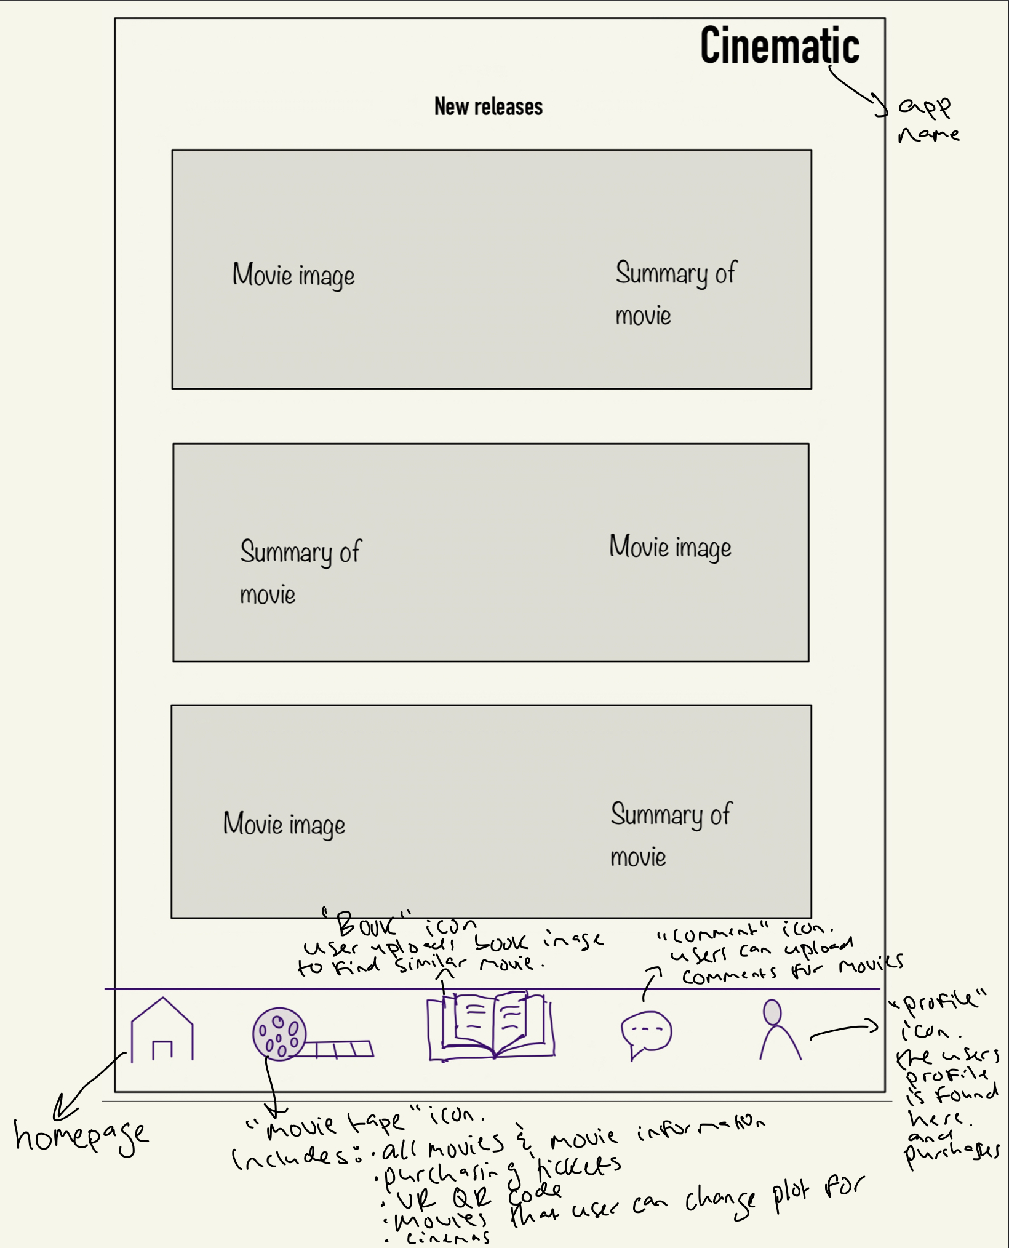
Functional & Non-Functional Test-Cases

- Write 3 additional test-cases (using the test-case template) for each of three abstracted high priority functional requirements (one test-case per requirement/use case).

Separate document

- Write 2 additional test-cases (using the test-case template) for each of the two most important non-functional requirements (one test-case per requirement).

Separate document

